**Name**: Abdelrahman Khaled Elsayed Ebrahiem

**B.N**: 446

**Edu mail**: [Abdelrahman195499@feng.bu.edu.eg](mailto:Abdelrahman195499@feng.bu.edu.eg)

**Topic**: Programming Languages

**GitHub Link:** https://github.com/AbdelrahmanKhaled826/ECE001

**GitHub Pages:** https://abdelrahmankhaled826.github.io/ECE001/

*Definition of Programming:*

Programming is defined as the process of writing instructions and directing commands to a computer or other device such as DVD players or audio and video receivers in modern communication systems, to guide that device and the inform how to manage the data or perform a series of required actions called an algorithm.

*Applications of Programming Languages:*

Computer programming languages allow us to give instructions to a computer in a language the computer understands. Just as many human based languages exist, there are an array of computer programming languages that programmers can use to communicate with a computer. The portion of the language that a computer can understand is called a “binary.” Translating programming language into binary is known as “compiling.” Each language, from C Language to Python, has its own distinct features, though many times there are commonalities between programming languages. These languages allow computers to quickly and efficiently process large and complex swaths of information. For example, if a person is given a list of randomized numbers ranging from one to ten thousand and is asked to place them in ascending order, chances are that it will take a sizable amount of time and include some errors.

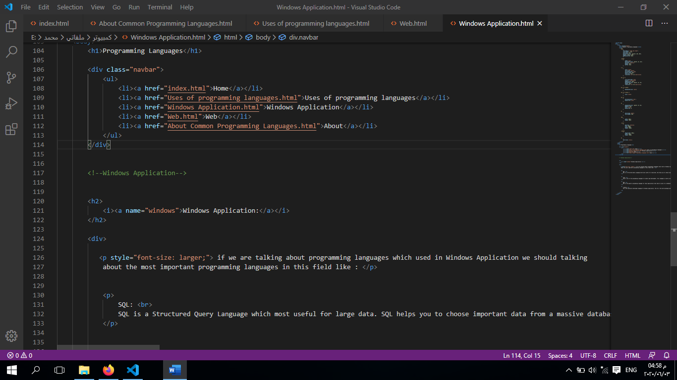*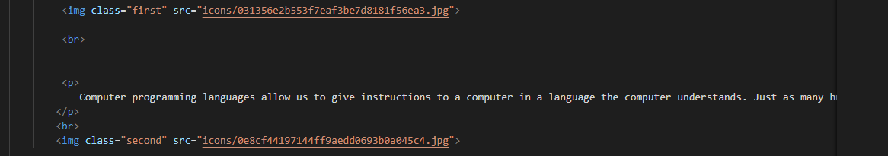Source Code:*

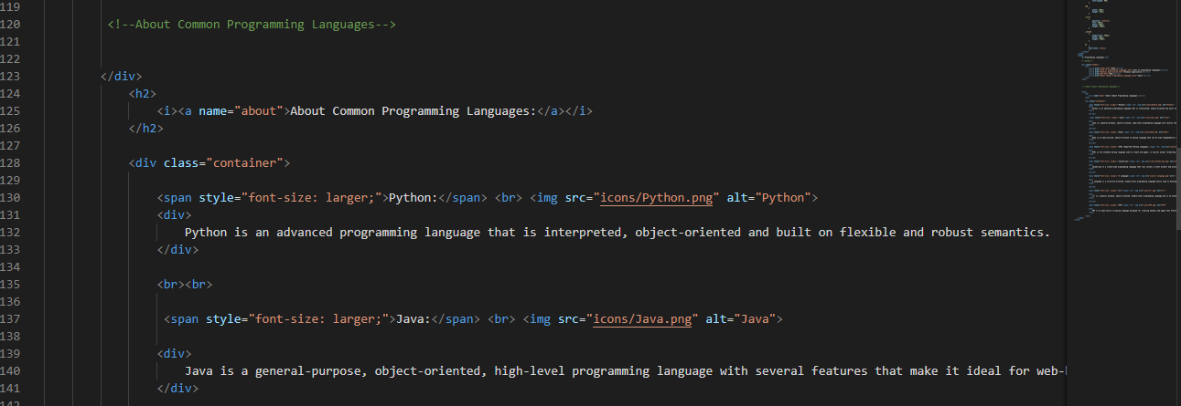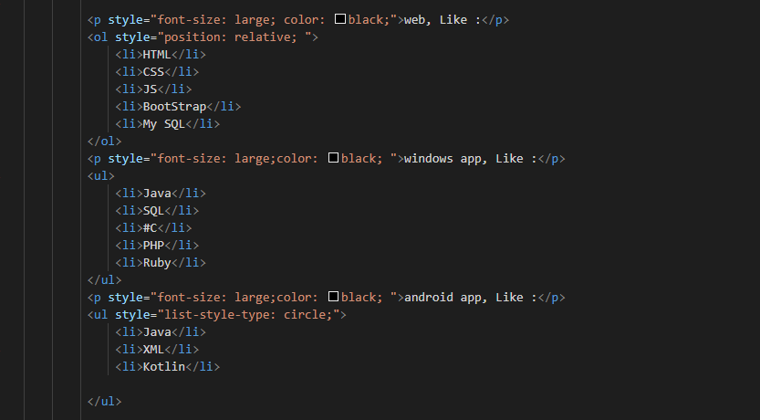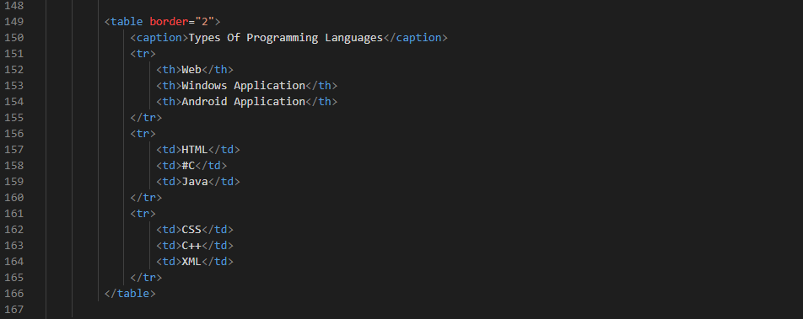

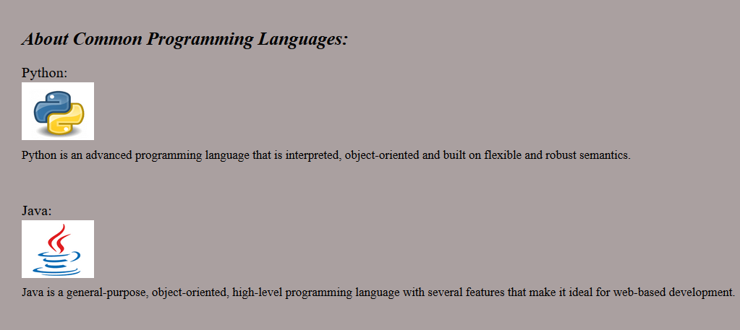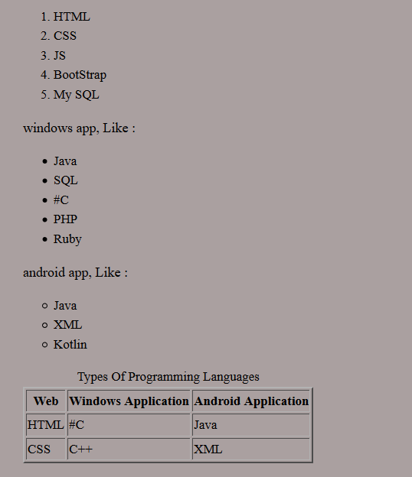*Screenshots:*

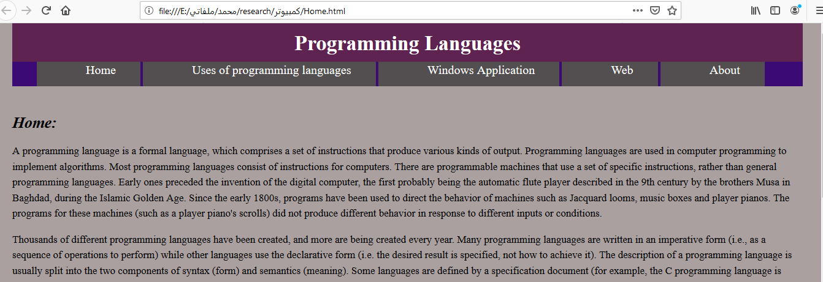

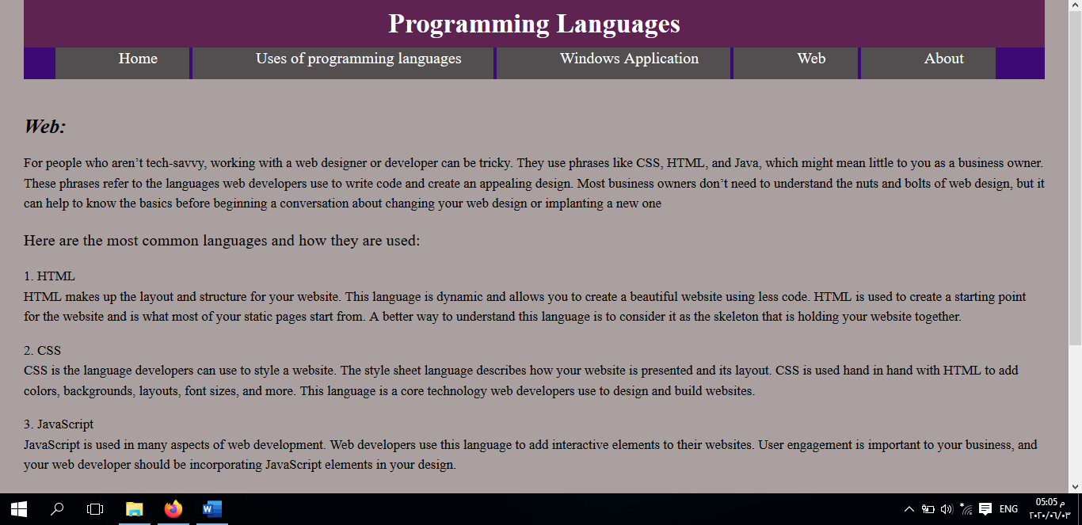

**References**

<https://www.quora.com/What-is-the-best-programming-language-to-develop-a-desktop-application-It-should-be-cross-platform-free-easy-to-learn-and-have-a-good-community>

<https://www.spinxdigital.com/blog/common-web-design-languages-what-they-do-and-why-you-need-them/>

<https://www.coursera.org/learn/programming-languages>

<https://www.computerscience.org/resources/computer-programming-languages/>